Final Project: ABC Company IT Help Desk Analysis

Jo De Leon

Southern New Hampshire University

**Data Report**

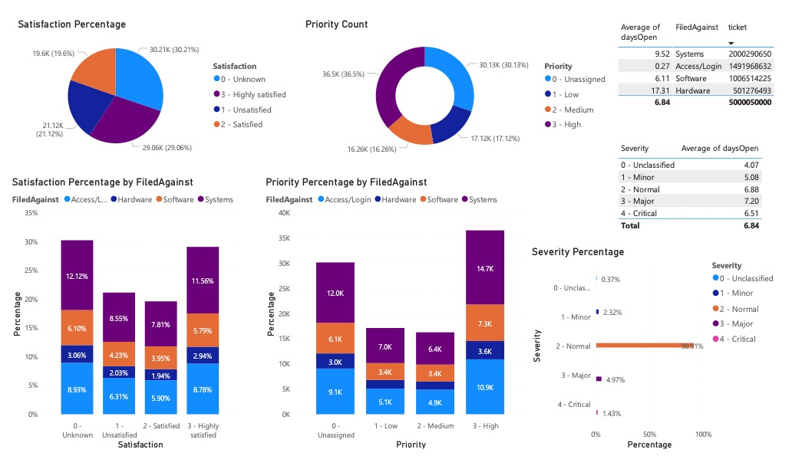

**Executive Summary Report**

For the purpose of the expansion of ABC Company, one of the data sets necessary to investigate are the IT Help Desk tickets. The analysis of these tickets will result into insights that could significantly improve the company’s customer satisfaction - which is a vital consideration for the maintenance and advancement of the company. The dissection of this data set into the number of tickets, number of high priority tickets, average response time, and other pertinent data model extracted from this data set allows for increased and improved engagement between the IT Help Desk and the customer. We will need to draw insights from the extracted data to better and quickly address improvements where needed for the company’s expansion.

I first inspected the data to ensure its relevance to the report requested. Upon finalizing its relevance, I moved to compile and clean the data in order to smoothly and properly create the visualizations to display the data. These steps taken in consecutive order makes certain that the accuracy and efficiency are as high as it can possibly be. The report outlines the necessary data used and involved in addressing the business questions. Focusing on key information like the number of tickets by FiledAgainst and their percentages and the average days it takes to resolve tickets by FiledAgainst. It is essential to draw out trends from these data which the visualizations make possible.

Upon reading this report, it is expected to have more targeted questions than answers. This is an indicator that the data displayed is valuable and relevant to the business question at hand. Multiple graphs, charts, and tables on a single page allows for a quicker decision-making as the data that really only needed are quite simple.

**Identity the Business Question**

The data set I selected is the IT Help Desk tickets. The way I would solve the business question of how to improve customer satisfaction and resolve issues quicker is by extracting and analyzing the data pertaining to this objective. By breaking down the data into simpler and comprehensible data visualizations, patterns or trends pertaining to the business question will be easier to draw out and make business decisions from.

**Making Sense of Data**

The data set provided includes the number of tickets, the id of the requestor, the requestor seniority, the IT assigned to the ticket, what the ticket was filed against, ticket type, severity, priority, how long the ticket was open, and how satisfied the customer was. Each column of data can be useful to address the business question because they provide the necessary parameters needed to compile the data and create reports. Since these data are measurable, they need only a bit of manipulation to map them back to the objective of the company which is to expand. This particular set of data is important to consider for this objective because the IT Help Desk engages directly with customers. A marketing data set would be of no use when needing to analyze customer satisfaction in regard to any IT issue. The columns of data I would particularly use are columns FiledAgainst, Severity, Priority, daysOpen, and Satisfaction. I intend to use these because these are data that when measured against each other will show patterns that directly involves how timely the tickets are resolved and how well each customer is satisfied.

**Business Intelligence**

By using the Power BI, I will be able to create a dashboard of charts and tables of the data that I think is pertinent to the business question. The Power BI’s features is incredibly useful and essentially significant for stakeholders to make decisions accordingly and timely. Upon importing the data into this tool, we are able to manipulate the data according to what stakeholders need and want to see. It will be much easier to neglect unnecessary data and highlight the data vital to the requested report.

**Guiding Questions**

The main questions I am concerned with in the context of what will improve customer satisfaction and decrease resolution time are the following. What are the percentages of each satisfaction category? Further into that, how are the percentages broken down according to what the tickets are filed against? In short, which FiledAgainst tickets garner the least satisfactory reviews? How many tickets are in high priority? What is the average of the days to resolve tickets? Per FiledAgainst? Per Severity? What is the percentage of high severity tickets?

Once the data is compiled and cleaned, I will create charts and graphs by carefully selecting columns pertaining to these set of question that ultimately address the business questions. Comparing the values attained through the visualization of these charts and graphs will certainly pave a way for drawing pivotal insights for the company.

**Visualization**

The visualizations I specifically chose for displaying this data are bar graphs, pie & donut charts, and tables. The reason being is that these are the simplest ways to present these data. Its readability and minimalism enable the stakeholder to see the data and almost immediately be able to infer what the data means right off the bat instead of looking at an excel sheet and is then left disoriented. These particular visualizations convey the information best because it shows a pattern of where the needs for improvement are.

You will find in this report a pie chart of the percentage of tickets by satisfaction, a donut chart of the count of the tickets by priority, a table of the average of days open of the tickets by FiledAgainst and how many tickets there are, a bar chart of the percentage of tickets by satisfaction by FiledAgainst, a bar chart of the priority percentage by FiledAgainst, a table of the average of days open of the tickets by severity, and a bar chart of the percentage of tickets by severity.

**Actionable Insights**

Based on these visualizations, we can infer that the longest average of days, which is about 17.31 days or about 2.5 weeks, to resolve a ticket are the tickets filed against Hardware even though these have the smallest amount of tickets compared to the rest. Out of all the tickets resolved, 21.12% of the customers were unsatisfied. Out of these 21.12%, the FiledAgainst with the most unsatisfied review are the Systems at 7.81%. It is also noteworthy to mention that the percentage per severity shows that while there almost and endless amount of tickets about 90.91% of them are normal.